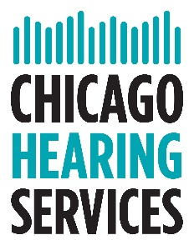

I, ___________________________, give permission to release my audiologic records to

____________________________ from Chicago Hearing Services. Please include any hearing

tests and hearing aid information.

______________________________________ Date_______________________

Patient